Multithreading – Thread Creation

- Refer the program in “thread_prg.c”. Complete the TBD sections , check the final solution for memory leak if any
A: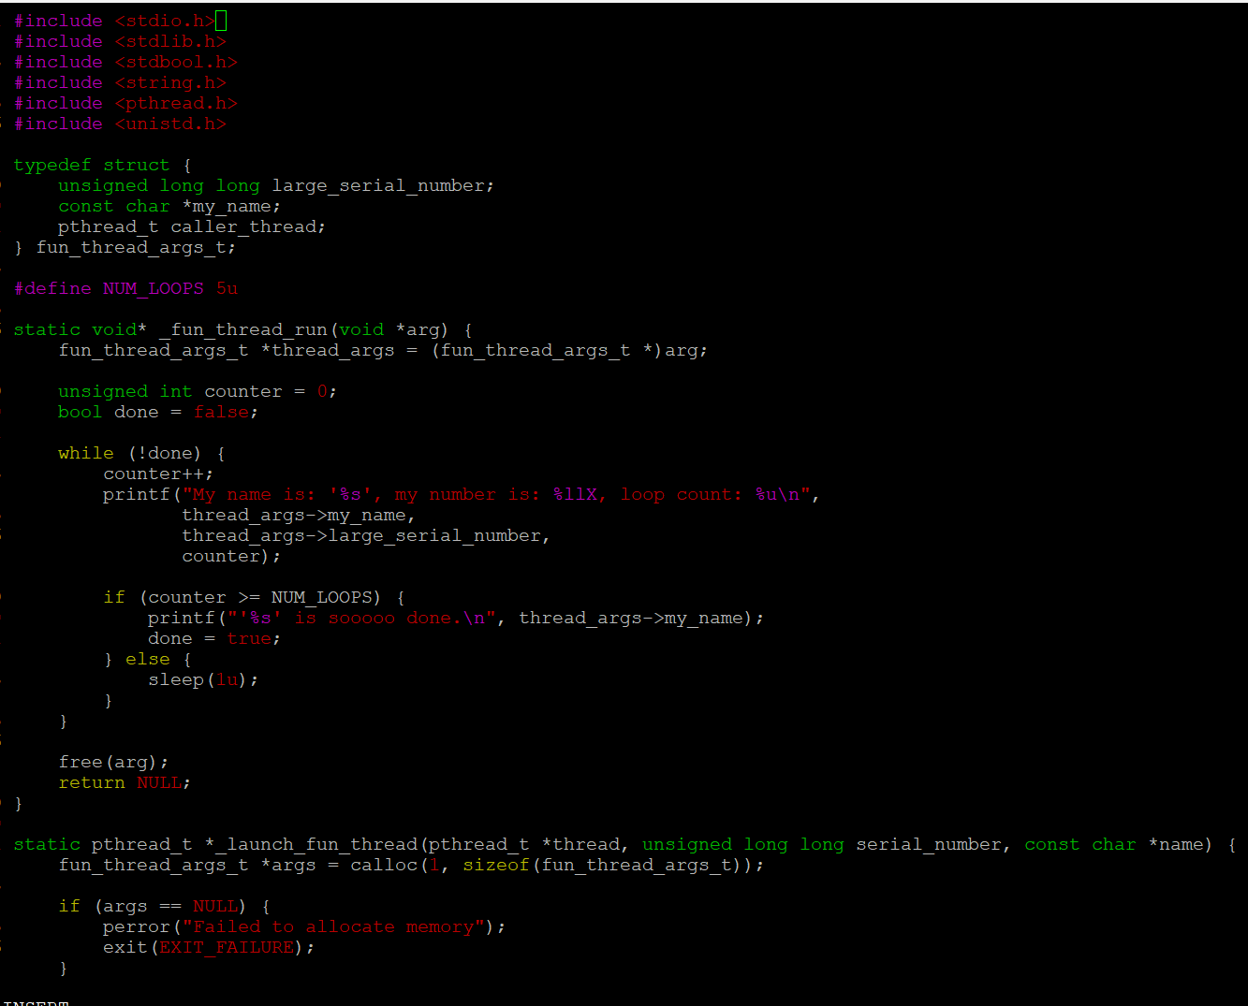
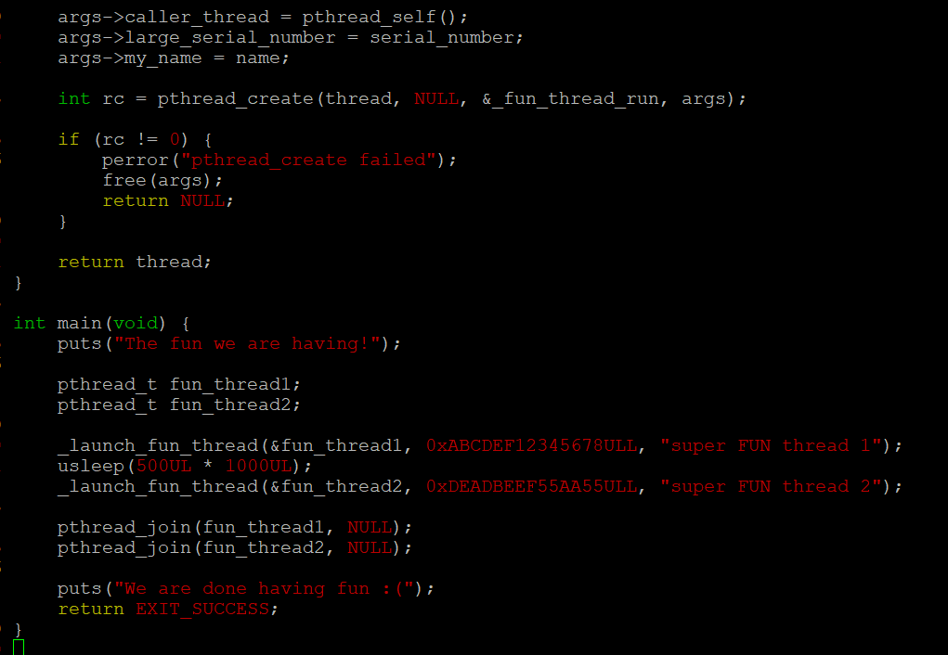
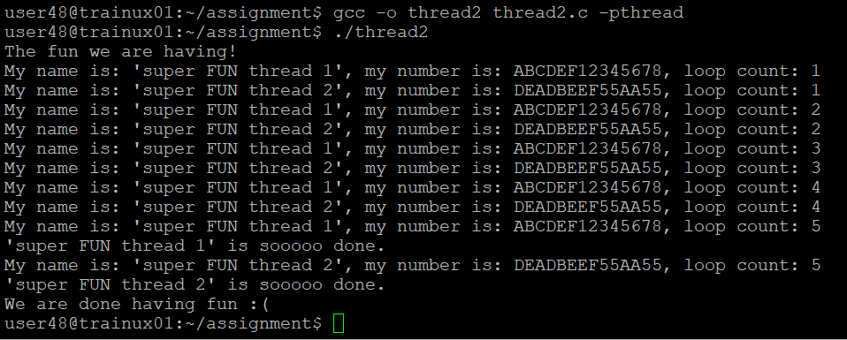
- Write a program
- to read a set of words as command line arguments and to create an array of threads (Consider a maximum of 5 words )
- process each word using an separate thread. Let each thread append “_ed” to the input word and return to main thread
- main thread to wait for completion of each thread, retrieve returned string display with thread number, free memory
A: